IT24101469

Lab6

1.

i.

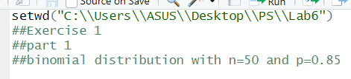

ii.



2.

i. 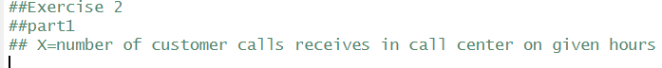

ii.

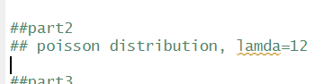

iii.

